Team 1 Open Source Air Quality Monitoring

Week 13: April 3rd 2022 - April 10th 2022

Sponsor: Dr. [David Burnett](mailto:dburnett@pdx.edu)

Advisor: Dr. John Acken

Team Members: [Adam Dezay](mailto:adezay@pdx.edu), [Manuel Garcia](mailto:manga2@pdx.edu), [Brandon Hippe](mailto:bhippe@pdx.edu), Mercedes Newton

**Team Review:**

* Team members are each working on specified sensor/component tasks.
* Enhanced gantt chart as shown in figures 1 and 2.
* Gantt chart and schedule for upcoming term (shown in figure 3).
* Moved team meetings to better accommodate schedules.
  + New times, effective today, are today Monday @ 7pm, Thursday advisor meeting @ 3pm and friday at 7pm
* Team changed meeting time with Dr. Acken for the upcoming term.
  + Starting April 6 we will be conducting Thursday 3pm meetings.
* Team prepared Thursday progress presentation for Dr Burnett
* Shifting emphasis to meshing codes

**Individual Review**

Adam Dezay:

Worked with Brandon on getting I2C with energia working. Yet to have full success connecting with our hardware, however prospects look positive on making progress this upcoming week.

Code finally compiles thanks to brandon. Connections to beadboard are too short so soldering might be needed.

Manuel Garcia:

Worked on planning logistics for the upcoming term and project goals. Spent a brief amount of time trying to integrate microcontroller with wireless network.

Brandon Hippe:

Got EnergyTrace working, and found the sleep() function in Energia, which puts the MSP430 into LPM3 mode. Created libraries for the SPS30 and SGP30, although they haven’t been tested yet. Started work on the main code for the node.

Mercedes Newton:

PM2.5 sensor updates - Working on connecting PM2.5 sensor to Energia and producing working code. Experiencing difficulty updating sensor libraries from arduino to Energia. Coordinated team planning for upcoming term and updated gantt charts.

**Gantt Chart and Timeline Updates:**

Below is both the timeline of the projected project progress for spring term. Figure 1 represents the gantt chart for the term with expected completion dates beginning March 25th. All specific dates for the upcoming term are specified in the table below.

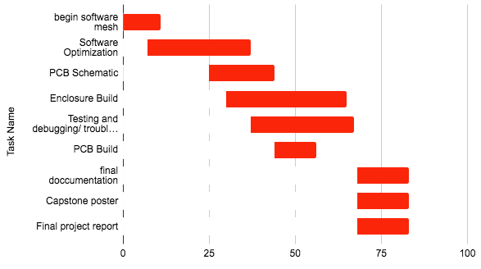

Figure One: Gantt chart for Spring term starting March 25th 2023

| Task Name | Start date | End date |
| --- | --- | --- |
| Begin software mesh | 3/25/2023 | 4/5/2023 |
| Software Optimization | 4/1/2023 | 5/1/2023 |
| PCB Schematic | 4/19/2023 | 5/8/2023 |
| Enclosure Build | 4/24/2023 | 5/29/2023 |
| Testing and debugging/ troubleshooting code | 5/1/2023 | 5/31/2023 |
| PCB Build | 5/8/2023 | 5/20/2023 |
| final documentation | 6/1/2023 | 6/16/2023 |
| Capstone poster | 6/1/2023 | 6/16/2023 |
| Final project report | 6/1/2023 | 6/16/2023 |

Table One: Tasks for spring term with expected completion dates *completion dates subject to change*